Title of your SMILS 2026 paper
(Font size 18)

Diana Droplet^{1,*}, Charles Chip² and Mike Microfluidics¹
Underline the presenting author

¹ Department, University, City, Country
² Company Name, City, Country
*E-mail: flow@somewhere.com

Introduction
Identify your main research results and elaborate how your work presented here differs from previous work of your and of other groups. Please use Times New Roman, size 11, regular, justified. References to literature should be made as [1].

Theory and Experimental procedure
After the introduction, present a detailed description of methods, device structures, and examples of specific results, whether experimental or theoretical. Remember to define all variables when using equations, such as this one describing the Reynolds number:

$Re=\frac{uL}{ν}$ (1)

where u is the flow speed, L the characteristic length scale and ν is the kinematic viscosity, respectively.

The structure of the paper following the introduction is up to you, it may include sections such as “Theory”, “Experimental”, “Results and Discussion”. The abstract should end with a “Conclusions” section. Figures can be inserted as below, Figure 1.

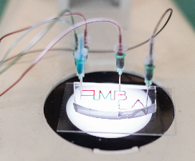 | Figure 1 Optical micrograph of a microfluidic chip developed at Uppsala University, Sweden.

Results and Discussion
Here you may present and discuss your most important findings.

Conclusion
The abstract is limited to one page. The deadline for submitting the abstract is April 12, 2026. Visit https://easychair.org/conferences/?conf=smils2026 to submit your abstract, in pdf format. The abstracts will be shared electronically with all conference participants, so please consider this when writing up your results.

Acknowledgments
The organizing committee thanks you for your interest in the SMILS 2026 meeting and we look forward to learning about your research.

References
[1] E. Xample, S. Mart, J. Irreproducible Results 56 126 (2016)
[2] D.J. Wiseguy, Fundamentals of miniaturisation (Science Press, New York 2000)
[3] B.A. Nerd, W.R. Freak, Proc. 50th Annual Turbulence Conference, London, UK, 2010, pp. 56-60

